1.

**AIM** : To write a DTD for the given XML.

**DESCRIPTION** :

DTD :

A DTD is a Document Type Definition.A DTD defines the structure and the legal elements and attributes of an XML document.

Use of DTD :

With a DTD, independent groups of people can agree on a standard DTD for interchanging data.

An application can use a DTD to verify that XML data is valid.

Types of DTD :

Internal DTD, External DTD

XML Elements : Elements are the main building blocks of both XML and HTML documents.

XML Attributes : Attributes provide extra information about elements.

Attributes are always placed inside the opening tag of an element. Attributes always come in name/value pairs.

PCDATA : Stands for Parsed Character Data

PCDATA is text that WILL be parsed by a parser. The text will be examined by the parser for entities and markup.

CDATA : Stands for Character Data.

CDATA is text that will NOT be parsed by a parser. Tags inside the text will NOT be treated as markup and entities will not be expanded.

Empty elements are declared with the category keyword EMPTY.

Elements with only parsed character data are declared with #PCDATA inside parentheses.

Elements declared with the category keyword ANY, can contain any combination of parsable data.

Elements with one or more children are declared with the name of the children elements inside parentheses.

The example above declares that the child element "message" must occur once, and only once inside the "note" element.

**PROGRAM CODE** :

<?xml version="1.0"?>

<!DOCTYPE stock [

<!ELEMENT stock (new-car,used-car*)>

<!ELEMENT new-car (model,price)>

<!ELEMENT used-car (model,price,mileage,condition*)>

<!ELEMENT model (#PCDATA)>

<!ELEMENT price (#PCDATA)>

<!ELEMENT mileage (#PCDATA)>

<!ELEMENT condition (#PCDATA)>

]>

<stock>

<new-car>

<model>Fiat Panda</model>

<price>12000</price>

</new-car>

<used-car>

<model>Fiat Bravo</model>

<price>4000</price>

<mileage>1000</mileage>

<condition>Good</condition>

</used-car>

<used-car>

<model>Ferrari</model>

<price>400000</price>

<mileage>100</mileage>

</used-car>

</stock>

**OUTPUT** :

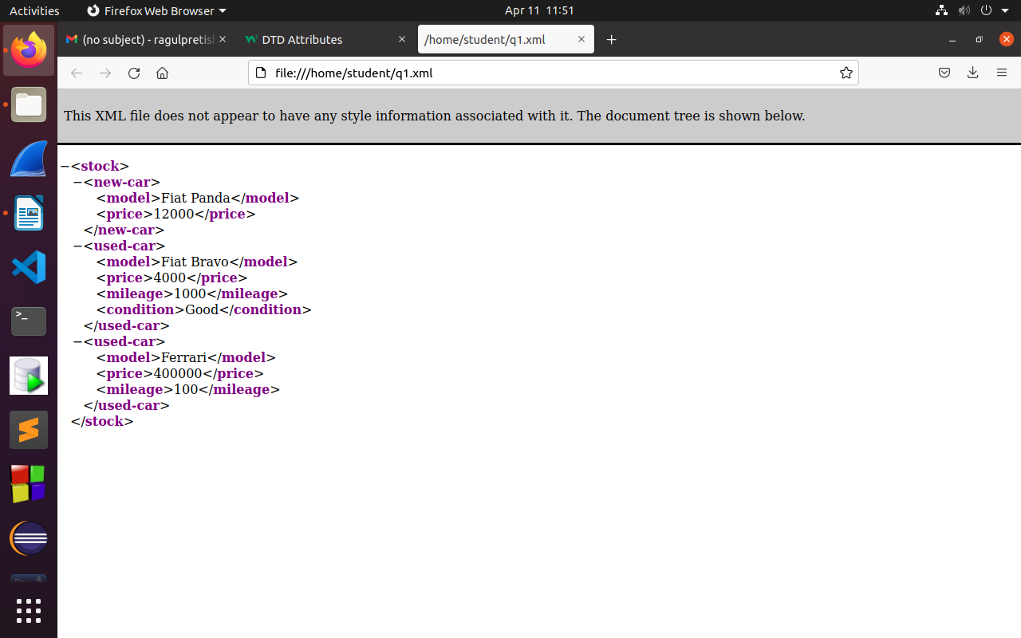

**RESULT ANALYSIS** :

XML is a markup language based on Standard Generalized Markup Language (SGML) used for defining markup languages. XML's primary function is to create formats for data that is used to encode information for documentation, database records, transactions and many other types of data.

2.

**AIM** :

To design DTD and XML for the bibliography of a book- Refer PPT Pageno-29

**DESCRIPTION** :

DTD :

A DTD is a Document Type Definition.A DTD defines the structure and the legal elements and attributes of an XML document.

• .In a DTD, attributes are declared with an ATTLIST declaration. Declaring Attributes

• The default-value can be one of the following: Value Explanation value The default value of the attribute #REQUIRED The attribute is required #IMPLIED The attribute is not required #FIXED value The attribute value is fixed.

• Occurrences of elements

• . Declaring Only One Occurrence of an Element (1 time) : <!ELEMENT element-name (child-name)>

• . Declaring Minimum One Occurrence of an Element(1 to N) : <!ELEMENT element-name (child-name+)>

• Declaring Zero or More Occurrences of an Element : : <!ELEMENT element-name (child-name*)>

• Declaring Zero or One Occurrences of an Element : <!ELEMENT element-name (child-name?)>

• Declaring either/or Content : <!ELEMENT student name,rollno,marks,(section|branch))>

**PROGRAM CODE** :

<?xml version="1.0"?>

<!DOCTYPE bibliography [

<!ELEMENT bibliography (book+)>

<!ELEMENT book (title, author*, publisher?, year?, section*)>

<!ATTLIST book ISBN ID #REQUIRED>

<!ATTLIST book price CDATA #IMPLIED>

<!ELEMENT title (#PCDATA)>

<!ELEMENT author (#PCDATA)>

<!ELEMENT publisher (#PCDATA)>

<!ELEMENT year (#PCDATA)>

<!ELEMENT i (#PCDATA)>

<!ELEMENT content (#PCDATA|i)*>

<!ELEMENT section (title, content?, section*)>

]>

<bibliography>

<book ISBN="A1234" price="400">

<title>Home Alone</title>

<author>GR Rohith</author>

<publisher>Hemananda</publisher>

<year>2022</year>

<section>

<title>Home Alone</title>

<content>

<i>Drama</i>

<i>Fun</i>

<i>Family</i>

</content>

</section>

</book>

<book ISBN="B123456" price="10000">

<title>Beast</title>

<author>Nelson Dilipkumar</author>

<publisher>Sun Pictures</publisher>

<year>2022</year>

<section>

<title>Beast</title>

<content>

<i>Action</i>

<i>Drama</i>

<i>dark Comedy</i>

</content>

</section>

</book>

</bibliography>

**OUTPUT** :

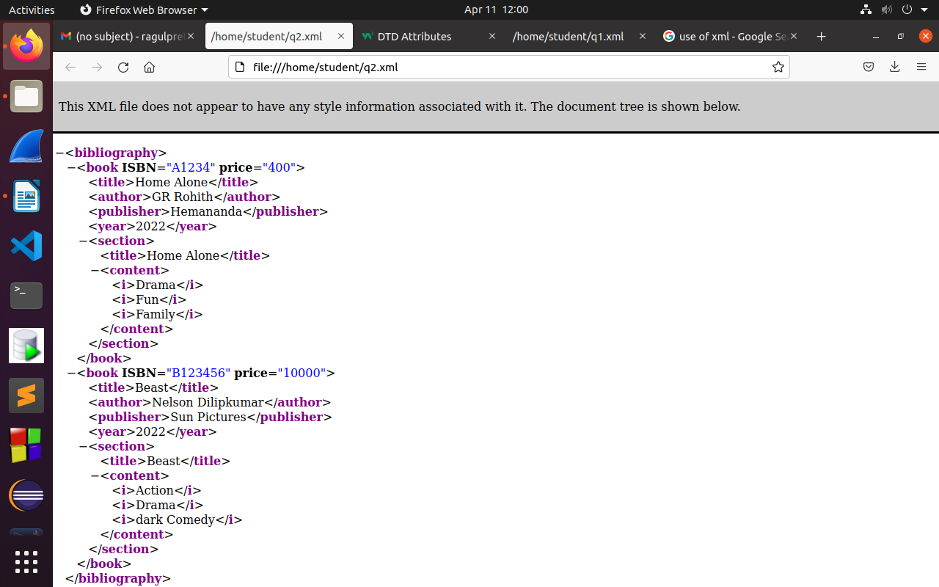

**RESULT ANALYSIS** :

Understood the use of occurences of elements and types of XML elements .

Further, learnt about how to write a DTD for a well-formed XML document.

3.

**AIM** : To write a DTD and XML for a collection of receipies.

**DESCRIPTION** :

• DTD : A DTD is a Document Type Definition.A DTD defines the structure and the legal elements and attributes of an XML document.

• Types of elements :

• . Element with text data( parsed character data): <!ELEMENT element-name (#PCDATA)>

• . Elements with Children (sequences) : <!ELEMENT element-name (child1)> or

<!ELEMENT element-name (child1,child2,...)>

• . Mixed Element: element allows child element and text data

• Empty Elements

• Empty elements are declared with the category keyword EMPTY:

• <!ELEMENT element-name EMPTY>

• Empty element may contain attributes.

**PROGRAM CODE** :

<?xml version="1.0"?>

<!DOCTYPE collection[

<!ELEMENT collection (description,recipe*)>

<!ELEMENT description ANY>

<!ELEMENT recipe (title,ingredient*,preparation,comment?,nutrition)>

<!ELEMENT title (#PCDATA)>

<!ELEMENT ingredient (ingredient*,preparation)?>

<!ATTLIST ingredient name CDATA #REQUIRED

amount CDATA #IMPLIED

unit CDATA #IMPLIED>

<!ELEMENT preparation (step*)>

<!ELEMENT step (#PCDATA)>

<!ELEMENT comment (#PCDATA)>

<!ELEMENT nutrition EMPTY>

<!ATTLIST nutrition protein CDATA #REQUIRED

carbohydrates CDATA #REQUIRED

fat CDATA #REQUIRED

calories CDATA #REQUIRED

alcohol CDATA #IMPLIED>

]>

<collection>

<description>

Some recipes used for the xml tutorial.

</description>

<recipe>

<title>Fried Rice</title>

<ingredient name="rice" amount="2" unit="4"/>

<ingredient name="salt" amount="0.5" unit="3"/>

<preparation>

<step>Preheat a large skillet or wok to medium heat. Pour sesame oil in the bottom. </step>

<step>Slide the onion, peas and carrots to the side, and pour the beaten eggs onto the other side. Using a spatula, scramble the eggs.</step>

<step>Add the rice to the veggie and egg mixture. Pour the soy sauce on top.</step>

</preparation>

<comment>

Lorem ipsum dolor sit amet consectetur adipisicing elit. Molestiae ipsum perferendis ducimus corrupti est eius. Repudiandae nihil nisi perspiciatis consequatur culpa suscipit laborum velit corporis, perferendis dolorum modi ipsam! Rerum velit reiciendis fugiat beatae. Maxime mollitia eaque ea nam voluptatem libero, nobis accusantium pariatur sed aliquid odit minima quae officiis.

</comment>

<nutrition protein="4.7g" carbohydrates="31g" calories="163" alcohol="0" fat="2.3g"/>

</recipe>

</collection>

**OUTPUT** :

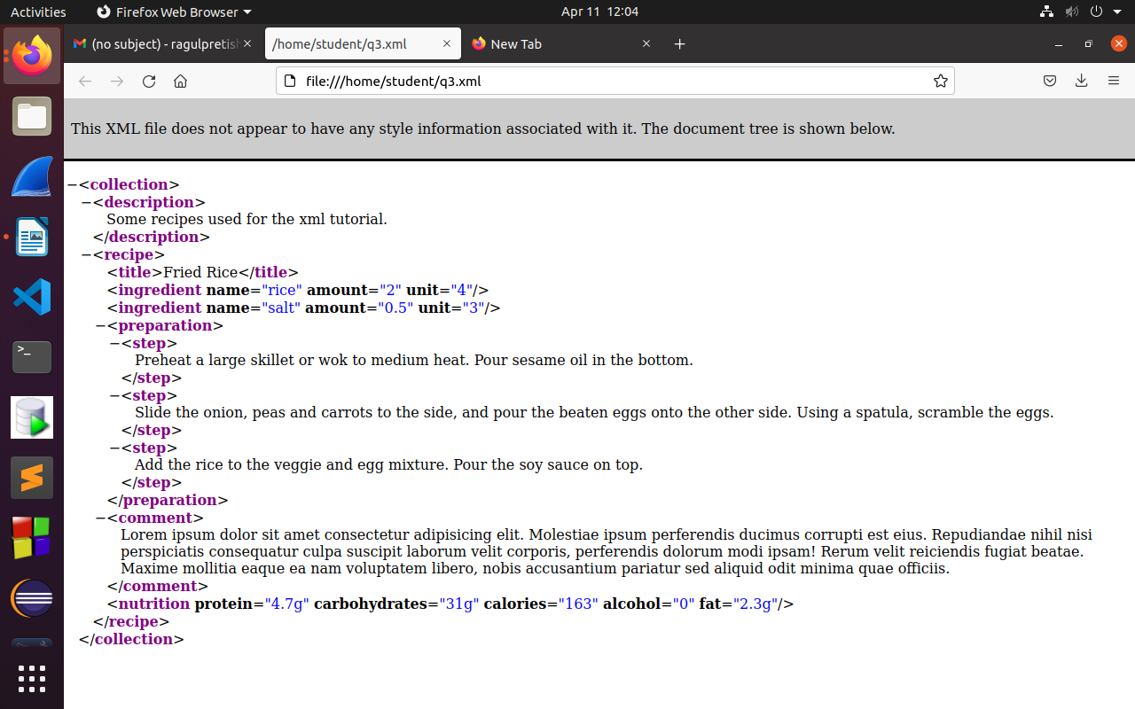

**RESULT ANALYSIS** :

Understood about the types of elements and the syntax of different XML elements and

how to mention the occurences of it. Also learnt about declaring the attributes of XML

elements. And finally how to validate it.